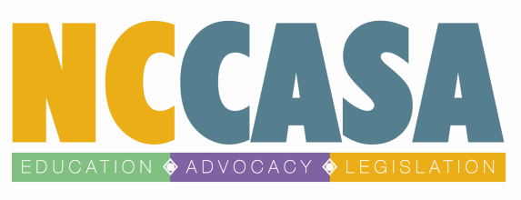

Campus Consortium Advisory Committee Membership
2013-2014

The Campus Consortium Advisory Committee will function as the primary planning and decision-making body for the implementation of the statewide Campus Consortium. We seek to create an Advisory Committee that will be composed of 6-8 members from around the state who represent the diverse communities, campuses, needs, and interests of colleges across North Carolina. Please read the following commitments and opportunities below to determine whether the appointment would work for you or would be a good match for someone you know.

Advisory Committee members will have the following opportunities:
- Making a difference and being part of a social change movement to effectively address the epidemic of sexual violence on college campuses.
- Participating in an innovative approach to strategic planning and campus mobilization that will lead to personal capacity building and skills development. These skills can be applied in a variety of work and community settings.
- Networking with others from a variety of diverse campuses, rape crisis centers, and perspectives with a shared commitment to addressing and preventing sexual violence on college campuses.
- Being part of forging a new path for sexual violence prevention that will inform and shape the future of the NCCASA Campus Consortium.

Advisory Committee members will commit to the following:
- The ability to meet at least 4x/year (meeting method and location negotiable).
- Assisting with the planning and implementation of Campus Consortium meetings, , trainings, and other opportunities as they arise.
- Sharing responsibilities such as note-taking, material preparation for meetings and events, assistance with securing meeting/event locations, small group facilitation, and meal-planning.
- Participation between meetings on other work that the Advisory Committee may take on, ie data projects, research, outreach, the creation of training tools, etc.
- Participation in a process that is respectful and constructive and that honors all participants’ diverse experiences.
- An attention to the integration of prevention, multiculturalism, and intersectionality in all aspects of the Campus Consortium work.

Please submit application to Jen Przewoznik, NCCASA’s Director of Prevention and Evaluation, at jen@nccasa.org or 919-871-1015. Thank you!

North Carolina Statewide Campus Consortium Advisory Committee Application

I am nominating: (circle one) Myself Someone Else

If “someone else”, does this person know they are being nominated?
(circle one) Yes NO

Name of Nominee: ______________________________

Affiliated School:________________________________

Job Title:_______________________________________

Nominee Contact Information:

Email:____________________

Phone:_____________________

Why do you think the you/the nominee would be a good fit for the Advisory Committee? (offers diverse perspective, brings specific skill set, etc.)

Do you think you/the nominee will be able to meet the commitments outlined on the previous page?

Please submit a short bio introducing yourself to the Campus Consortium.

Thank you for your help with this important process!!

