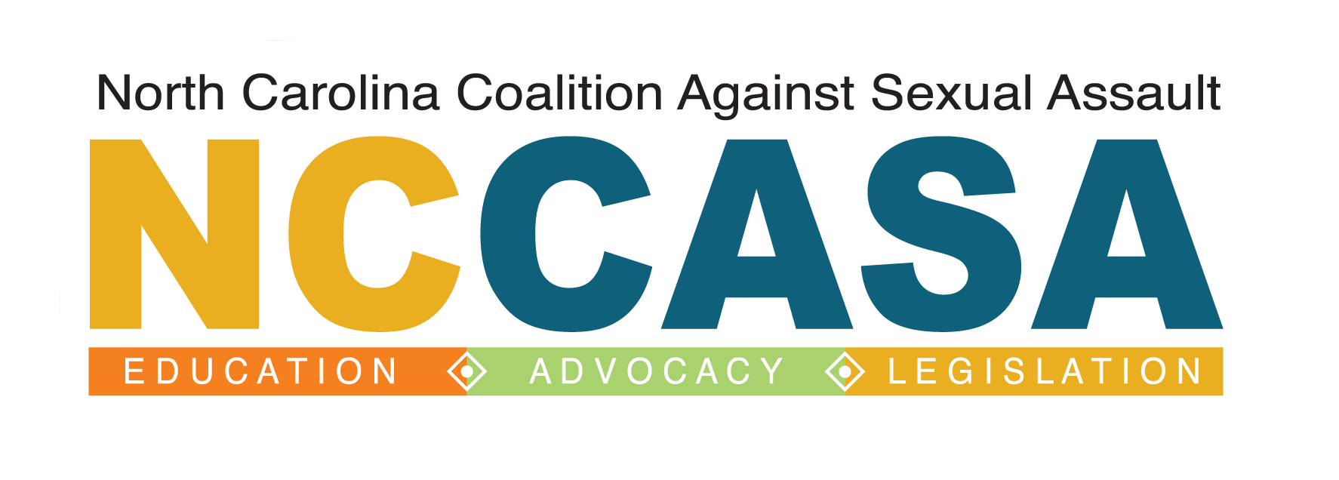
NCCASA Member Meeting
Monday, June 16th, 2014 in Raleigh
10:00am – 3:30pm
Registration must be received by Wednesday, June 11th

Name: Title:
LUNCH IS ON YOUR OWN
Contact Information

Agency:

Phone:
Email:

Special needs?
This meeting is free to current NCCASA members.

NCCASA Member (please circle): Yes/No

I the undersigned agree to the registration, payment and cancellation policies stated herein, and agree to pay the full amount to reserve training space for this registrant.

Signed ______________ _____________ Date ___________________
Exec. Dir./Fin. Mgr./Individual Registrant

E-mail registration to:

Kristen Howe
kristen@nccasa.org

